Creative Writing Revision Titles (1B)

Use the following story titles to create plans or short stories which follow the success criteria:
Success Criteria
- Imaginative and interesting
- Follow the narrative structure of: opening, rising action, climax, falling action and resolution
- Use varied sentence structures
- Use TIPTOP paragraphing
- Use punctuation for effect
- PANIC to open sentences
- Interesting vocabulary
- Good spelling
- Make sure it is clear and you have checked it makes sense
AO5: Creative Writing Language skills
BANDING | AO5 Communication and organisation
HIGHEST (Band 5) | - the writing is fully coherent and controlled (plot and characterisation are developed with detail, originality and imagination)  - the writing is clearly and imaginatively organised (narrative is sophisticated and fully engages the reader’s interest)  - structure and grammatical features are used ambitiously to give the writing cohesion and coherence  - communication is ambitious and consistently conveys precise meaning
AO5: Transactional Writing Language Skills
BANDING | Criteria: Communication and organisation
HIGHEST  (Band 5) | - shows sophisticated understanding of the purpose and format of the task  - shows sustained awareness of the reader / intended audience  - appropriate register is confidently adapted to purpose / audience  - content is ambitious, pertinent and sophisticated  - ideas are convincingly developed and supported by a range of relevant details  - there is sophistication in the shape and structure of the writing  - communication has ambition and sophistication

Story Titles
- Imagine you’re digging in your garden and find a large nugget of gold.
- Write about something ugly — war, fear, hate, or cruelty–but find the beauty (silver lining) in it.
- Begin your story. The asteroid was hurtling straight for Earth…
- The unfortunate loo roll incident.
- You’ve got to have faith.
- Begin your story. There’s a guy sitting on a park bench reading a newspaper…
- It was love at first sight.
- Begin your story. He turned the key in the lock and opened the door. To his horror, he saw…
- Begin your story. Silvery flakes drifted down, glittering in the bright light of the harvest moon. The blackbird swooped down…
- Begin your story. The detective saw his opportunity. He grabbed the waitress’s arm and said…
- Begin your story. There are three children sitting on a log near a stream. One of them looks up at the sky and says…
- Begin your story. There is a magic talisman that allows its keeper to read minds. It falls into the hands of a young politician…
- Begin your story. You thought dragons didn’t exist…
- Nature is beautiful.
- Begin your story. The doctor put his hand on her arm and said gently, “You or the baby will survive. Not both. I’m sorry.”
- Begin your story. The nation is controlled by…
- You walk into your house and it’s completely different — furniture, decor, all changed. And nobody’s home.
- Write about one (or both) of your parents.
- Begin your story. The most beautiful smile I ever saw…
- Begin your story. I believe that animals exist to…
- A twinkling eye.
- Good versus evil.
- Drifting off to sleep.
- The Holiday Disaster
- The Holiday Surprise
- A great idea
- The treasure
- Begin your story. That’s when it all went wrong
- Deception
- The Package

Language 1B: Creative writing tasks
Task 1: revise the structure of an essay – see below
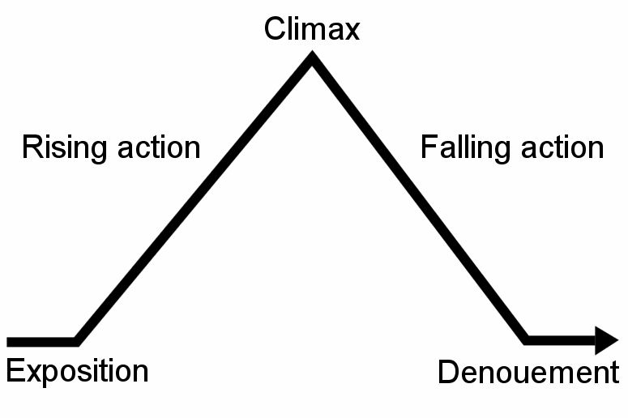

Exposition; introduction The exposition is the part of a story that introduces important background information to the audience; for example, information about the setting, events occurring before the main plot, characters' back stories, etc. Exposition can be conveyed through dialogues, flashbacks, character's thoughts, background details or the narrator telling a back-story.

Rising action In the rising action, a series of events build toward the point of greatest interest. The rising action of a story is the series of events that begin immediately after the introduction of the story and builds up to the climax. These events are generally the most important parts of the story since the entire plot depends on them to set up the climax and ultimately the satisfactory resolution of the story itself.

Climax The climax is the turning point, which changes the main characters fate. This is normally a high point of action, tension or drama.

Falling action During the falling action, the conflict between the main character and the other characters unravels.. The falling action may contain a moment of final suspense, in which the final outcome of the conflict is in doubt.

Dénouement; Ending This means that events from the end of the falling action to the actual ending scene of the drama or narrative. Conflicts are resolved, creating normality for the characters and the release of tension and anxiety, for the reader.
Task 2: create vocabulary word banks for some of the titles
Task 3: practice writing examples of similes, metaphors and personification
Simile – uses like or as to compare
Metaphor – compares as if something is something else
Personification – compares something as if it has human characteristics
Task 4: find examples of short stories online and read these – decide whether they are good or bad examples – peer assess them
WWW
EBI
Give reasons for your thoughts and ideas
Improve the story if you don’t like it

Task 5: develop your vocabulary by seeking out unusual words and creating your own wonderful word wall

Task 6: learn the spellings of words that you know you often get wrong
Use the following spelling strategies to help you: 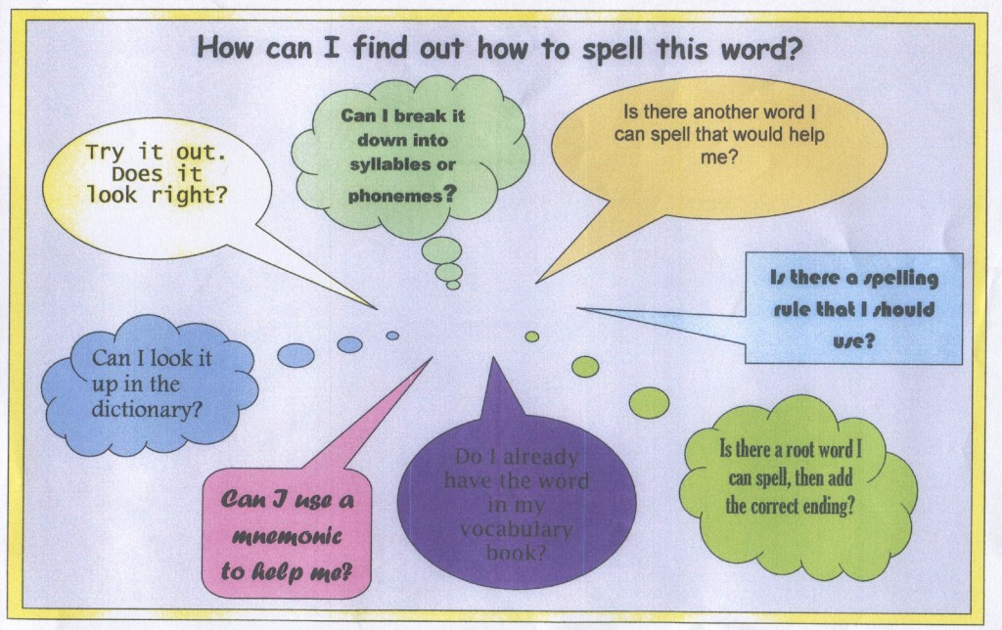
Task 7: create a guide to writing an interesting, engaging and well-structured story
Task 8: Log onto http://www.bbc.co.uk/skillswise/english and do some of the grammar tests to help you with the rules, or log onto your SAMLEARNING account and practice some of the tests on their for grammar, spelling, punctuation etc.
Task 9: practice using the following punctuation in your writing

The Punctuation Guide

. The full stop used at the end of a sentence to indicate a strong pause in the writing. Without this your writing does not make sense

, The comma is generally used in four ways 1 – to separate items in a list. 2 – before a connective. 3 – After an introductory phrase at the start of a sentence. 4 – in a complex sentence to separate clauses.

! An exclamation mark is used to indicate someone is shouting, show emotion and to show surprise. You should only ever use one in your work.

? A question mark comes at the end of a question, which usually begins with; who, what, where, when, which, why, can, how etc.

: This colon can be used to show that two ideas in a sentence are related and to introduce a list

; The semi-colon is used to show a break in the sentence if there are two closely related ideas and to show an idea that is related to the sentence, but is too short for an extra sentence.

… Ellipsis is used to indicate that something is missed out or to show it is a cliff-hanger

Task 10: practice writing short stories or introductions to short stories
Task 11: practice your sentence structures and varying these for effect:

The Structure of a Sentence – Simple, Compound and Complex
A simple sentence contains only a single clause (idea), whereas compound and complex sentence can contains at least two clauses.

The Simple Sentence
The most basic type of sentence is the simple sentence, which contains only one clause. A simple sentence can be as short as one word:
Run!
Usually, however, the sentence is a little longer than this. All of the following are simple sentences, because each contains only one clause:
Melt!
Ice melts.
The ice melts quickly.
The ice on the river melts quickly under the warm March sun.
Lying exposed without its blanket of snow, the ice on the river melts quickly under the warm March sun.
As you can see, a simple sentence can be quite long -- it is a mistake to think that you can tell a simple sentence from a compound sentence or a complex sentence simply by its length.

The Compound Sentence
A compound sentence consists of two or more independent clauses(or simple sentences) joined by connectives: for, and, nor, but, or, yet, so.:
Simple
Canada is a rich country.
Simple
Still, it has many poor people.
Compound
Canada is a rich country, but still it has many poor people.
They are used to connect ideas and to avoid pausing:
Today at school Mr. Moore brought in his pet rabbit, and he showed it to the class.
A compound sentence is most effective when you use it to create a sense of balance or contrast between two (or more) equally-important pieces of information:
Montréal has better clubs, but Toronto has better cinemas.

The Complex Sentence
A complex sentence contains one independent clause and at least one dependent clause. Unlike a compound sentence, however, a complex sentence contains clauses which are not equal. Consider the following examples:
Simple
The boy was cold. He had been playing football.
Compound
The boy was cold, as he had been playing football.
Complex
The boy, who had been playing football, was cold.
In the first example, there are two separate simple sentences: "The boy was cold" and "He had been playing football." The second example joins them together into a single sentence with the co-ordinating conjunction "as”; clauses that could still stand as independent sentences, they are entirely equal, and the reader cannot tell which is most important. In the third example, however, the sentence has changed quite a bit: the first clause, "who had been playing football," has become incomplete, or a dependent clause.
A complex sentence is very different from a simple sentence or a compound sentence because it makes clear which ideas are most important.

