Revision Titles and Stimulus Pictures for descriptive and creative writing (1B) AQA
GOOD ANSWERS FOR DESCRIPTIVE WRITING WILL:

- Maintain the same tense –Past is easier but present is fine too.
- Vary sentence starts and lengths - Short sentences can be as powerful as long ones!
- Ambitious vocabulary & a range of techniques –Similes, Metaphor, Personification etc
- Start high up-weather, then start to zoom in and look at different details – think camera techniques!
- Include a range of punctuation for effect – meaning is shaped well with commas, semi colons etc.
- Beginning links in some way with the end – perhaps consider how the scene changes
- Clear and coherent and uses paragraphs – Paragraph links if you’re really looking to impress

Some things you could focus on for the picture part of the task – descriptive writing:
Set the scene, describe the weather, birds, outside of the place – objects
Look at the scene as a whole – What are people in general doing?
Zoom in on a particular group/image
Zoom in on a particular person/part of the image within the group
Zoom in on another group
Zoom in on a couple of people within the group
Return to the scene and look at how it changes as the day draws to a close – link back to something at the beginning

GOOD ANSWERS FOR THE CREATIVE WRITING WILL:
Success Criteria
- Imaginative and interesting
- Follow the narrative structure of: opening, rising action, climax, falling action and resolution
- Use varied sentence structures
- Use TIPTOP paragraphing
- Use punctuation for effect
- PANIC to open sentences
- Interesting vocabulary
- Good spelling
- Make sure it is clear and you have checked it makes sense

Story Titles
- Write the opening of a story about a war-torn country
- Write the opening of a story about an avoidable accident
- Write the opening of a story about an ordinary town centre
- Write the opening of a story about a spectacular event (such as Rio Carnival)
Write a description suggested by these pictures:
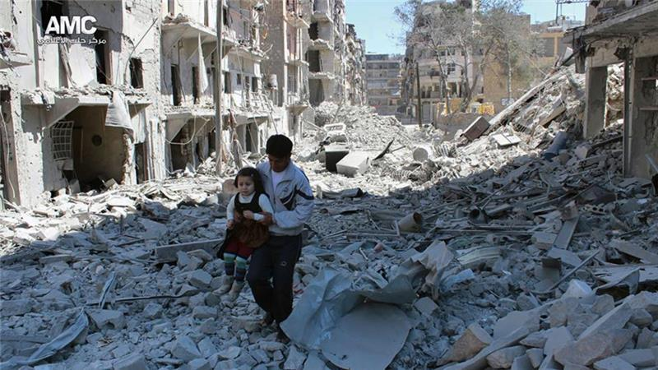
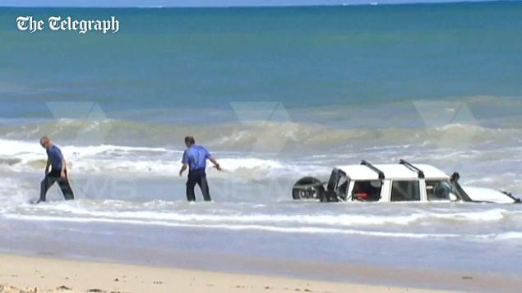
Or, choose a picture you have copy and paste it and then write a description inspired by the picture.

Language 1B: Creative writing tasks – General improvement tasks
Task 1: revise the structure of an essay – see below
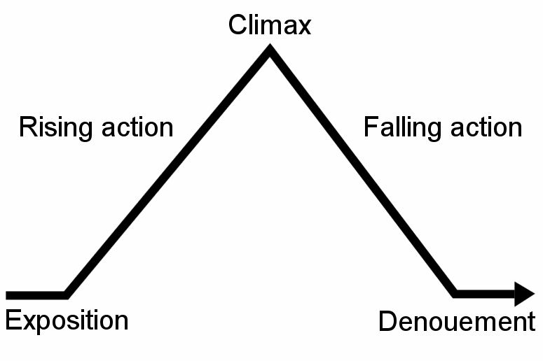

Exposition; introduction The exposition is the part of a story that introduces important background information to the audience; for example, information about the setting, events occurring before the main plot, characters' back stories, etc. Exposition can be conveyed through dialogues, flashbacks, character's thoughts, background details or the narrator telling a back-story.

Rising action In the rising action, a series of events build toward the point of greatest interest. The rising action of a story is the series of events that begin immediately after the introduction of the story and builds up to the climax. These events are generally the most important parts of the story since the entire plot depends on them to set up the climax and ultimately the satisfactory resolution of the story itself.

Climax The climax is the turning point, which changes the main characters fate. This is normally a high point of action, tension or drama.

Falling action During the falling action, the conflict between the main character and the other characters unravels.. The falling action may contain a moment of final suspense, in which the final outcome of the conflict is in doubt.

Dénouement; Ending This means that events from the end of the falling action to the actual ending scene of the drama or narrative. Conflicts are resolved, creating normality for the characters and the release of tension and anxiety, for the reader.
Task 2: create vocabulary word banks for some of the titles
Task 3: practice writing examples of similes, metaphors and personification
Simile – uses like or as to compare
Metaphor – compares as if something is something else
Personification – compares something as if it has human characteristics
Task 4: find examples of short stories online and read these – decide whether they are good or bad examples – peer assess them
WWW
EBI
Give reasons for your thoughts and ideas
Improve the story if you don’t like it

Task 5: develop your vocabulary by seeking out unusual words and creating your own wonderful word wall

Task 6: learn the spellings of words that you know you often get wrong
Use the following spelling strategies to help you: 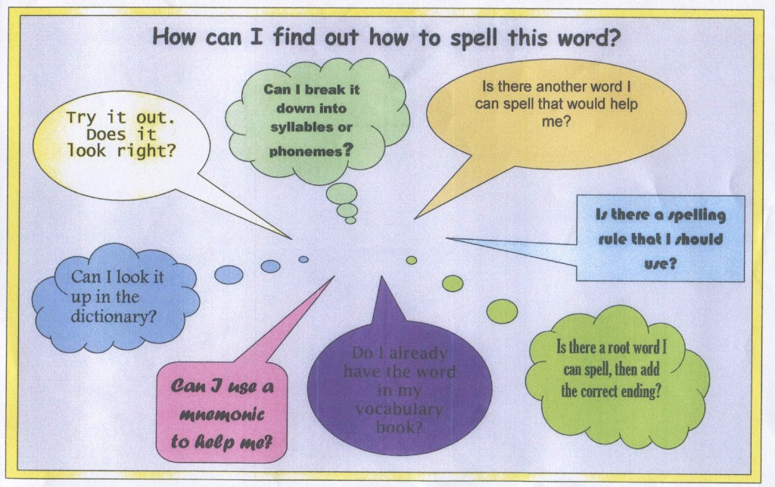
Task 7: create a guide to writing an interesting, engaging and well-structured story
Task 8: Log onto http://www.bbc.co.uk/skillswise/english and do some of the grammar tests to help you with the rules, or log onto your SAMLEARNING account and practice some of the tests on their for grammar, spelling, punctuation etc.
Task 9: practice using the following punctuation in your writing

The Punctuation Guide

. The full stop used at the end of a sentence to indicate a strong pause in the writing. Without this your writing does not make sense

, The comma is generally used in four ways 1 – to separate items in a list. 2 – before a connective. 3 – After an introductory phrase at the start of a sentence. 4 – in a complex sentence to separate clauses.

! An exclamation mark is used to indicate someone is shouting, show emotion and to show surprise. You should only ever use one in your work.

? A question mark comes at the end of a question, which usually begins with; who, what, where, when, which, why, can, how etc.

: This colon can be used to show that two ideas in a sentence are related and to introduce a list

; The semi-colon is used to show a break in the sentence if there are two closely related ideas and to show an idea that is related to the sentence, but is too short for an extra sentence.

… Ellipsis is used to indicate that something is missed out or to show it is a cliff-hanger

Task 10: practice writing short stories or introductions to short stories
Task 11: practice your sentence structures and varying these for effect:

The Structure of a Sentence – Simple, Compound and Complex
A simple sentence contains only a single clause (idea), whereas compound and complex sentence can contains at least two clauses.

The Simple Sentence
The most basic type of sentence is the simple sentence, which contains only one clause. A simple sentence can be as short as one word:
Run!
Usually, however, the sentence is a little longer than this. All of the following are simple sentences, because each contains only one clause:
Melt!
Ice melts.
The ice melts quickly.
The ice on the river melts quickly under the warm March sun.
Lying exposed without its blanket of snow, the ice on the river melts quickly under the warm March sun.
As you can see, a simple sentence can be quite long -- it is a mistake to think that you can tell a simple sentence from a compound sentence or a complex sentence simply by its length.

The Compound Sentence
A compound sentence consists of two or more independent clauses(or simple sentences) joined by connectives: for, and, nor, but, or, yet, so.:
Simple
Canada is a rich country.
Simple
Still, it has many poor people.
Compound
Canada is a rich country, but still it has many poor people.
They are used to connect ideas and to avoid pausing:
Today at school Mr. Moore brought in his pet rabbit, and he showed it to the class.
A compound sentence is most effective when you use it to create a sense of balance or contrast between two (or more) equally-important pieces of information:
Montréal has better clubs, but Toronto has better cinemas.

The Complex Sentence
A complex sentence contains one independent clause and at least one dependent clause. Unlike a compound sentence, however, a complex sentence contains clauses which are not equal. Consider the following examples:
Simple
The boy was cold. He had been playing football.
Compound
The boy was cold, as he had been playing football.
Complex
The boy, who had been playing football, was cold.
In the first example, there are two separate simple sentences: "The boy was cold" and "He had been playing football." The second example joins them together into a single sentence with the co-ordinating conjunction "as”; clauses that could still stand as independent sentences, they are entirely equal, and the reader cannot tell which is most important. In the third example, however, the sentence has changed quite a bit: the first clause, "who had been playing football," has become incomplete, or a dependent clause.
A complex sentence is very different from a simple sentence or a compound sentence because it makes clear which ideas are most important.

